BITS PILANI, DUBAI CAMPUS
DUBAI INTERNATIONAL ACADEMIC CITY, DUBAI

SECOND SEMESTER 2023 – 2024
COURSE: CSF303 (Computer Network)
COMPONENT: Tutorial Sheet 8 (Solution) DATE: 25th March 2024

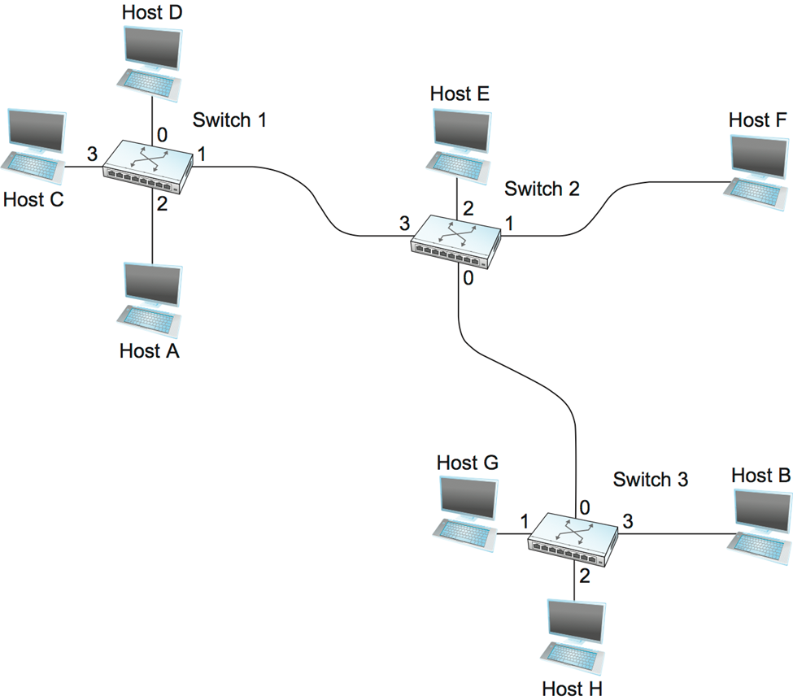
Mac address Port/Interface TTL

Q1. With the above diagram Let initially all the switching tables are empty. Let the IP address of the computer Host A is IPA and let its MAC address is MACA. Similar IP and MAC addresses are derived for all computers with letters B,C,D,E,F,G and H. Let initially the switching tables are empty. Draw the switching tables for switch1 and switch2 and switch3 incrementally after transfer of every packet.
- Let Host D sends packet to Host E.
- Let Host H send packet to Host E
- Host F sends packet to Host C.
- Let Host H send packet to Host F.
- Let Host G sends packet to Host E
Swith 1 =>
MAC Add | Port | TTL
D | 0 | 60 min
E | 1 | 60 min
2) H | 1 | 60 min
3) F | 1 | 60 min
3) C | 3 | 60 min
4) H | 1 | 60 min
5) G | 1 | 60 min
Switch 2=>
MAC | Port | TTL
D | 3 | 60 min
E | 2 | 60 min
2) H | 0 | 60 min
3) F | 1 | 60 min
3) C | 3 | 60 min
4) H | 0 | 60 min
4) F | 1 | 60 min
5) G | 0 | 60 min
5) E | 2 | 60 min
Switch 3 =>
MAC | Port | TTL
D | 0 | 60 min
2) H | 2 | 60 min
2) E | 0 | 60 min
3) F | 1 | 60 min
4) H | 2 | 60 min
4) F | 0 | 60 min
5) G | 1 | 60 min
5) E | 0 | 60 min

- How many broadcast and collision domains are shown in the graphic assuming only the default VLAN is configured on the switches?

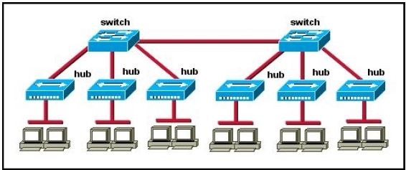

Only router can break up broadcast domains but in this exhibit no router is used so there is only 1 broadcast domain. For your information, there are 7 collision domains in this exhibit (6 collision domains between hubs & switches + 1 collision between the two switches).

- How many broadcast and collision domains are shown in the graphic assuming only the default VLAN is configured on the switches?

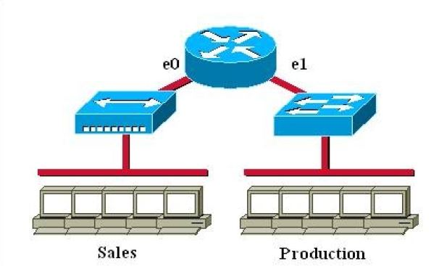

Answer:

Only router can break up broadcast domains so in the exhibit there are 2 broadcast domains: from e0 interface to the left is a broadcast domain and from e1 interface to the right is another broadcast domain.

Both router and switch can break up collision domains so there is only 1 collision domain on the left of the router (because hub doesn’t break up collision domain) and there are 6 collision domains on the right of the router (1 collision domain from e1 interface to the switch + 5 collision domains for 5 PCs in Production).

- How many broadcast and collision domains are shown in the graphic assuming only the default VLAN is configured on the switches?

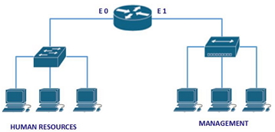

Ans: 2, 5
- Consider the below diagram of interconnecting 2 VLAN switches. Let the left switch is called as VLAN switch1 and right switch called as VLAN switch2. How many switching tables will be maintained by each VLAN ? Suppose Computer at port2 in switch 1 wants to send a packet to computer at port3 in Switch2 but it does not have the MAC address of destination. Which computers will receive ARP request packets?
  - Draw the ARP request packet at the output of port 8 switch1, port 16 of switch 1, and port 3 of switch 2. (without expanding Data field)
  - Draw the ARP response (without expanding data field) at port 3 at switch 2and at port 1 at switch2.
Mac address of a computer in any port is assigned like Mac2Swich1 or Mac2Swtch2 where 2 represents in which port number and switch indicates at which switch). Similarly assigned for computers in other ports.


1
8
9
10
2
7
…
Electrical Engineering
(VLAN ports 1-8)
Computer Science
(VLAN ports 9-15)
15
…
2
7
3
Ports 2,3,5 belong to EE VLAN
Ports 4,6,7,8 belong to CS VLAN
5
4
6
8
16
1

